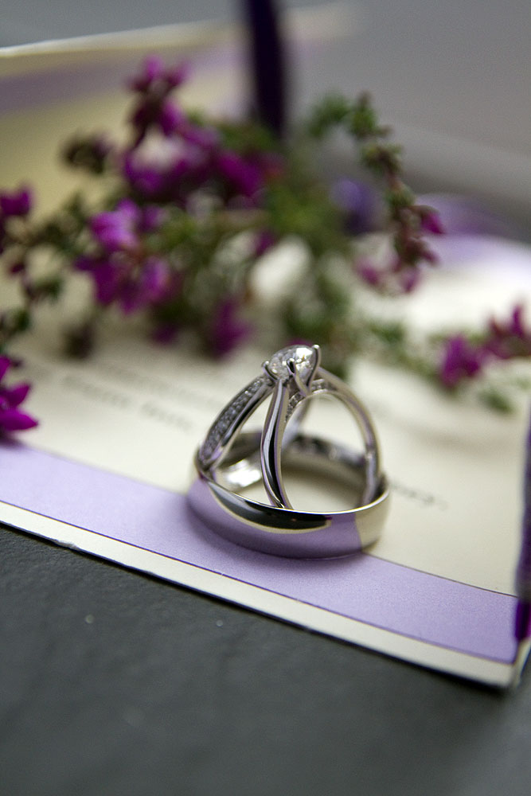

Pricing Collections 2025

* Basic £499.00

Includes ceremony coverage and an hour of formal family portraits, processed images supplied on USB stick in presentation box, images can also be viewed via private website gallery.

* Premium £899.00 up to 8 consecutive hours

Coverage from getting ready venue to ceremony, formal portrait session after ceremony, including speeches, cake cutting first dance. Photos to be viewed via private website gallery. Including wedding album, images supplied on USB stick in presentation box.

* Dream £1499.00 up to 10 consecutive hours

Includes a pre wedding shoot at venue of choice.

Prep to Party package, Coverage from getting ready venue for both Bride and Groom subject to locations to ceremony, formal portrait session after ceremony, including speeches, cake cutting first dance etc. Photos to be viewed via private website gallery. Including wedding album and parent mini albums, images supplied on USB stick in presentation box. Prepared slideshow put to royalty free music.

Above prices subject to change depending on exact travel requirements and possible over night stays if required